

**Southern Maine Sea Kayaking Network**

**GUIDELINES FOR TRIP PARTICIPANTS**

**January 2021**

Welcome to SMSKN! To ensure a fun and safe paddling experience for all our members, we ask that those who sign up for our trips follow the guidelines below.

1. Understand that SMSKN has no prequalification criteria of any kind for Organizers or participants, and that even the individual(s) who have volunteered to organize a trip may be less experienced than you. You are responsible for your own safety.
2. Make sure you have electronically signed the online SMSKN Participant Agreement on smskn.net/Club Documents.
3. Read the trip description closely and be honest about your equipment and abilities before signing up. Know your limits and comfort zone. It’s your decision whether or not to paddle that day depending on conditions and your paddling abilities, and don’t go out or follow if you’re not comfortable. See the Trip Level designations on page 2 of this Guideline.
4. Make sure you have the appropriate equipment – ocean-ready kayak (16 ft. recommended) with sealed bulkheads, spray skirt, PFD, pump, paddle float, clothing suitable for water temperature, at a minimum - before signing up. Shorter boats may be suitable on some trips; check with the organizer. Recreational boats less than 14 ft. are typically not suitable for ocean conditions.
5. Please don’t sign up for a trip unless you really intend to go and amend your response promptly if your plans change**.**
6. Please be on time.Note that on SMSKN trips, the posted trip time is usually the launch, or “butts in boat” time. Arrive early enough to get your boat ready and check conditions.
7. Let the Organizer know of any limiting health conditions or other concerns that you may have.
8. Stay with the group, especially in areas of high boat traffic. Likewise, keep track of other paddlers and let the group know if someone is falling behind. Let the Organizer know if you wish to leave the group and go off on your own. That’s okay.
9. Have fun!

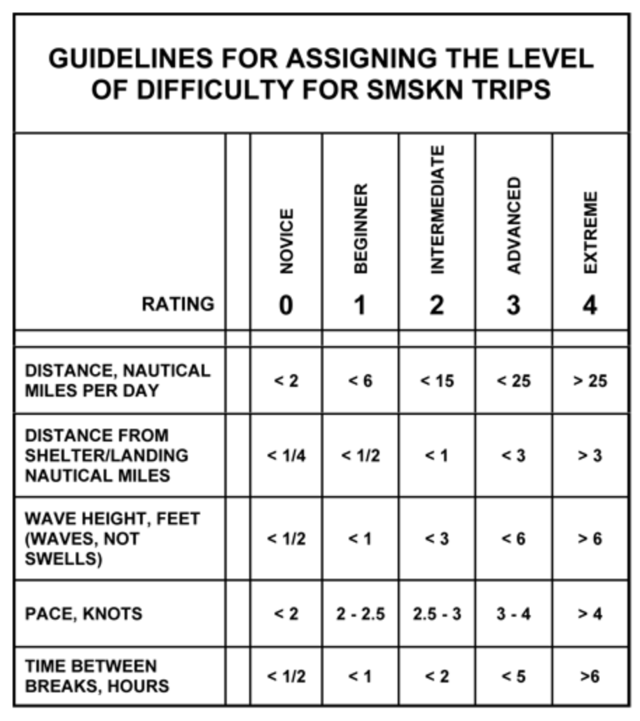

All criteria are approximate and are intended for general categorization only.