Southern Maine Sea Kayaking Network

GUIDELINES FOR TRIP ORGANIZERS
January 2021

Due to Meetup features, only individuals designated as Meetup “Organizers” can post trips on the SMSKN Meetup home page. Organizer status is open to all SMSKN members and is conferred to individuals who request it by the President or Board members. While we encourage all who are interested to become Organizers, we ask that Organizers comply with the guidelines below when posting and conducting trips to help ensure the safety of our members and the viability of the Club.

- Post a clear and accurate description of the trip and required equipment on Meetup description. This is important so that people don’t sign up for trips for which they are not prepared or equipped. Specify trip length (NM) and duration, any known hazards, gear requirements (drysuits, helmets), and trip level per the chart on page 2. A pdf and sprayskirt are required on all our trips and specifying boat length (usually 16 ft+) is recommended to prevent the 12’ rec boats from showing up, which happens.

- Know the weather and tide forecast for the day of your trip. Attendees may not check. Be cautious about describing weather in the announcement, since conditions can change significantly over a few days. If conditions worsen and trip level changes, amend the writeup and if necessary notify attendees, which can be done through the Meetup page.

- Check the Meetup page regularly before the trip and respond to communications from participants. You can change your profile settings on Meetup to get emails of these.

- Be specific about departure time. Traditionally, the trip start time is the launch or “butts in boats” time for SMSKN trips.

- Make sure everyone has signed the online Participant Agreement and have some hard copies for those who haven’t. Hang onto hard copies and give them to club leadership, either in hard copy or electronically.

- Discuss the planned route with the group before setting out. Describe the latest weather forecast and tides, find out who has radios and confirm the channel, and discuss any safety concerns. Remind everyone that they are responsible for their own safety and ask that the group stays reasonably close together, particularly in areas of boat traffic. Ask participants to notify you if they want to split off from the group.

- Leave a Float Plan in a visible place in your car and with a party on-shore.

- Keep an eye on the group during the trip, and make sure you come back with everyone you left with.

- Have fun!

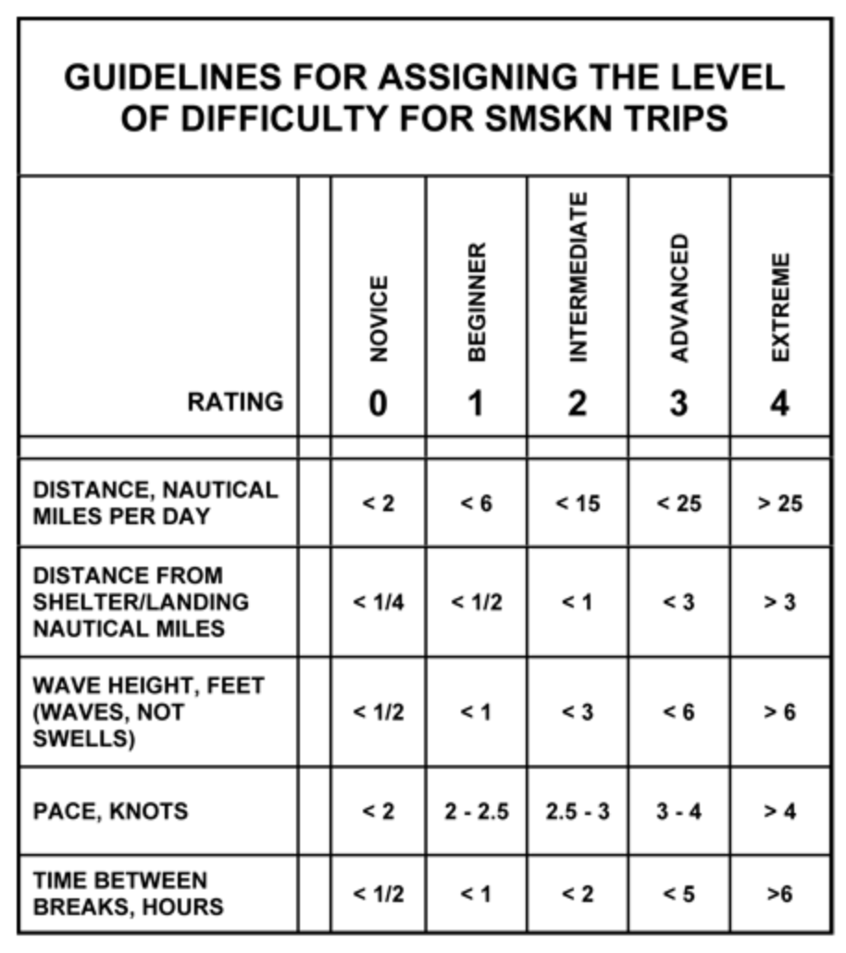

All criteria are approximate and are intended for general categorization only.

